Adverse Event or Unexpected Death Reporting
Animal Ethics Committee
AE
008

The Australian code for the care and use of animals for scientific purposes 2013 (the Code) requires that any unexpected adverse events be reported to the AEC.

The Ethics Advisor, Animal Welfare Advisor – Research & Teaching, and the Animal Ethics Committee will review this report form.

Submit completed application into IRMA system under the Documents tab.

animal.ethics@murdoch.edu.au
Animal Ethics Office

(08) 9360 7366

All applications are to be submitted in the IRMA system as attachments to a coversheet.

Part A - |  | Project information
 | Permit Number (*****/**): |  |  |  |  |  |  |  |  |  |  |  | Protocol ID (***):
 | Project Title:
 | Chief Investigator / Supervisor:
 | Title |  |  |  | Given Name |  |  |  |  |  |  | Surname
 | Form completed by:
 | Role on the project:
Part B - |  | Summary
 | Tick one box that best applies to the purpose of this research. |  |  |  |  |  |  |  |  |  |  |  |  | Tick one only
 | (i) |  | Found Dead
 | (ii) |  | Illness/injury (survived)
 | (iii) |  | Euthanased
 |  |  | Describe method:
 | (iv) |  | Other (e.g. power failure, inclement weather)
 |  |  | Provide details:
Part C - |  | Animal Details
 | Animal ID:
 | Species:
 | Genotype:
 | Sex:
 | Procedure: (Experiment / Aim #)
 | Date and Time of incident:
 | Location of incident:
 | Have you informed the AWO / AEO? |  |  |  |  |  |  |  | Yes No
 | Are other animals at risk? |  |  |  |  |  |  |  | Yes No
 | Provide details:
 | Post Mortem Examination (PME)? |  |  |  |  |  |  | Yes No |  |  | Has this report been attached? |  |  |  |  | Yes No
 | Provide details:
Part D - |  | Details of incident
 | Provide information on the details of the incident.
 | Include an outline of the details of the event and the circumstances leading up to it; what is the likely cause of the event; how does the event impact on the animal and the research project in both the immediate and long-term; what is the total number of injuries / deaths out of the total population at risk; what is the health status of the remaining animals?
 | What further action will be taken to prevent a similar adverse incident occurring in the future?
 | Include information regarding what remedial action will be taken (including treatments, medicines, etc.); what, if any, procedures / practices need to be modified as a result of the event?

AE
013

How to submit Animal Ethics forms in IRMA:
for Animal Ethics forms
Submission Information

All forms are received and processed through the IRMA system. To do this, you will need to create a “Coversheet” in IRMA and attach this form and any supporting documents as part your submission.

- Begin by creating a Coversheet. Log into IRMA and click on “Researcher Profile” (found in the top right-hand corner of your screen). If you do not have IRMA access, lodge a request with IT through ServiceNow.

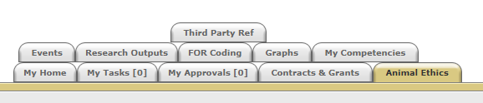

- Click on the “Animal Ethics” tab:

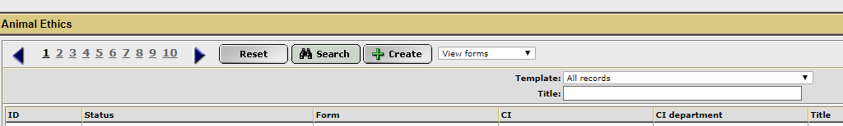
- Ensure the drop-down option is showing as “View Forms”, and click the “Create” button to create a new coversheet:

- Select the Unexpected Death or Euthanasia / Adverse Events coversheet from the drop-down list (shown below), link the coversheet to the relevant project by clicking the “Search” button, and then click “Next”:
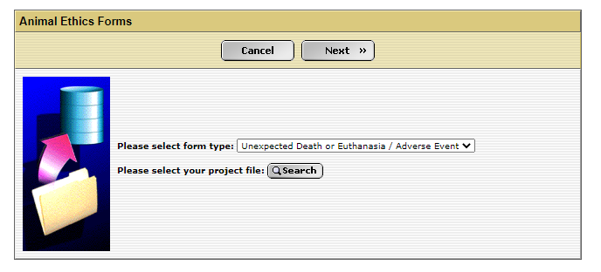

- A new screen will appear (see below). Click on the weblink and download the “Unexpected Death or Euthanasia / Adverse Events form.
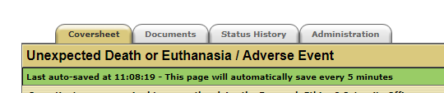

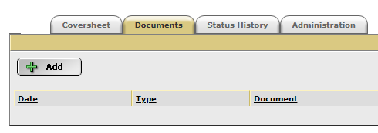
- When the form has been downloaded and completed, save the document to your computer, and upload a copy into the IRMA coversheet you have just created. Click on the “Documents” tab and upload the form by clicking the “+ Add” button.

Select the most relevant option from the drop list provided

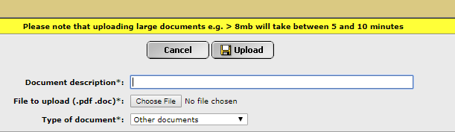

Include any other supporting documentation, e.g. post mortem reports in the “Documents” tab. Ensure each attachment is clearly labelled in the “Document Description” box.

- Once this form, and all other supporting documentation, have been uploaded into IRMA, return to the “Coversheet” tab and click the “Submit” button.

TASK COMPLETE

