AE
007
Animal Ethics Committee
Amendment Form
Scientific use of animals undertaken by Murdoch University staff and students must comply with the requirements of the Australian Code for the Care and Use of Animals for Scientific Purposes, 2013 (the Animal Code) and the Animal Welfare Act, 2002 (WA). Persons using animals for scientific purposes must consider the 3 Rs: Replacement, Reduction, and Refinement at all times.

Responses to ALL questions must be provided on this form. Applicants should not simply refer to an attachment without summarising relevant material on this form.
Animal Ethics Office
(08) 9360 7366
animal.ethics@murdoch.edu.au
All forms are to be submitted in the IRMA system as attachments to a coversheet.

Part A - |  | Personnel information
 | Permit Number (*****/**) & Protocol ID (***) |  |  |  |  |  |  |  |  |  | Date of Original Approval
 | Project Title
 | Chief Investigator / Supervisor
 | Title |  |  | Given Name |  |  |  |  |  | Surname
 | Form Completed by
 | Role on the project
Part B - |  | Amendment Summary
2.1 | Currently Approved  Summarise the project as currently approved. For example, provide the lay summary submitted with the original application.
2.2 | Experimental Protocol Changes  Briefly list each of your requested changes.
 | (i)
 | (ii)
 | (iii)
 | (iv)
 | (v)
2.3 | Justification  Why are the proposed changes required?
2.4 | Keywords
 | Provide a list of and definitions for any technical terms and acronyms to assist the AEC to understand this amendment.
 | Term |  |  |  |  |  |  | Lay Explanation
Part C - |  | Extension of Approved Period  ONLY complete this section if the amendment is requesting a change to the current permit expiry date.
3.1 | Does this amendment involve any extension of the Approval Period for holding the animals? |  |  |  |  |  |  |  |  |  |  |  |  |  | Yes No
 | If yes, provide details of how long the extension is being sought for
 | (i) |  | Proposed Amendment Start Date (dd/mm/yyyy):
 | (ii) |  | Currently Approved Expiry Date (dd/mm/yyyy):
 | (iii) |  | Extension of Approval Period – Proposed New Expiry Date (dd/mm/yyyy):
Part D - |  | Animal Numbers  ONLY complete this section if the amendment is requesting a change (either increase or substitution) to the animal numbers.
4.1 | Does this amendment involve an increase in animal numbers?  If yes, will the increase be: |  |  |  |  |  |  |  |  |  |  |  |  |  |  | Yes No
 | (i) |  | Up to 3 additional animals or no more than 10% of approved numbers. |  |  |  |  |  |  |  |  |  |  |  |  | Yes No
 | (ii) |  | More than 3 additional animals or more than 10% of approved numbers. |  |  |  |  |  |  |  |  |  |  |  |  | Yes No
 | Fill out the below section if you require changes to the number or type of animals used for this project.
4.2 | Currently Approved |  |  |  |  |  |  |  |  |  |  | Number of Animals Allocated
 | (Species / Strain & Common Name) |  |  |  |  |  |  |  |  |  |  | (Current total)
4.3 | Requested Change |  |  |  |  |  |  |  |  |  |  | Change in Numbers
 | (Species / Strain & Common Name) |  |  |  |  |  |  |  |  |  |  | (+ / - how many) |  |  |  |  |  | (New total)
Part E - |  | Sex, Strain, Species or Source  ONLY complete this section if the amendment is requesting changes to the existing approval animal sex, strain, species or source.
5.1 | Does this amendment involve:
 | (i) |  | A change in the sex, strain, species or source of animals being used? |  |  |  |  |  |  |  |  |  |  |  |  |  | Yes No
 |  |  | If yes, provide details.
Part F - |  | Location, Housing or Transportation  ONLY complete this section if the amendment is requesting changes to the existing location, animal housing or transportation method.
6.1 | Does this amendment involve:
 | (i) |  | A change to the housing / location, length of housing, or the method of transport of the animals? |  |  |  |  |  |  |  |  |  |  |  |  |  | Yes No
 |  |  | If yes, provide details of the proposed changes and explain why these are needed.
Part G - |  | Non-Surgical Procedures  ONLY complete this section if the amendment is requesting changes to non-surgical procedures
7.1 | Does this amendment involve:
 | (i) |  | A change to specimen collection times?  (i.e. change of times with no increase to overall frequency) |  |  |  |  |  |  |  |  |  |  |  |  |  | Yes No
 |  |  | If yes, provide details.
 | (ii) |  | An increase to the frequency and/or quality of specimen collection? |  |  |  |  |  |  |  |  |  |  |  |  |  | Yes No
 |  |  | If yes, provide detailed justification for the proposed change.
 | (iii) |  | Any change to non-surgical procedures where the procedures will become less frequent or less invasive for the animals? |  |  |  |  |  |  |  |  |  |  |  |  |  | Yes No
 |  |  | If yes, provide details of the requested changes, include pharmaceutical dosages and routes of administration if appropriate.
 | (iv) |  | Does this amendment involve any change to non-surgical procedures that may lead to an increase in frequency or invasiveness of procedures for the animal? |  |  |  |  |  |  |  |  |  |  |  |  |  | Yes No
If yes, provide details of the requested changes and a suitable justification; include details on how ANIMAL WELLBEING will be supported including:
- Monitoring, assessment and treatment of post procedural pain and distress (including details of pharmaceutical dosages and routes of administration if appropriate.
- Criteria for intervention and/or euthanasia
Part H - |  | Surgical Procedures  ONLY complete this section if the amendment is requesting changes to the surgical procedures.
8.1 | Does this amendment involve:
 | (i) |  | Any change to a surgical procedure where the procedures will become less invasive for the animal? |  |  |  |  |  |  |  |  |  |  |  |  |  | Yes No
 |  |  | If yes, provide details of the requested changes; include pharmaceutical dosages and routes of administration if appropriate.
 | (ii) |  | Any change to a surgical procedure where this is likely to lead to greater impact on the animal? |  |  |  |  |  |  |  |  |  |  |  |  |  | Yes No
If yes, provide details of the requested changes and a suitable justification; include details on how ANIMAL WELLBEING will be supported including:
- Monitoring, assessment and treatment of post procedural pain and distress (including details of pharmaceutical dosages and routes of administration if appropriate.
- Monitoring schedule including changes to monitoring sheets
- Criteria for intervention and/or euthanasia.
(Note: this change may require the submission of a new application).
Part I - |  | Euthanasia Method  ONLY complete this section if the amendment is requesting changes to the currently approved euthanasia method.
9.1 | Does this amendment involve:
 | (i) |  | Any change to the methods of euthanasia, where the change is likely to result in less impost on the animal? |  |  |  |  |  |  |  |  |  |  |  |  |  | Yes No
 |  |  | If yes, provide details of the proposed changes and explain why it is needed.
 | (ii) |  | Any change to the methods of euthanasia, where the change is likely to result in greater impact on the animal? |  |  |  |  |  |  |  |  |  |  |  |  |  | Yes No
 |  |  | If yes, provide details of the proposed changes and provide a suitably detailed explanation.
Part J - |  | Other  ONLY complete this section if the amendment is requesting other changes not listed, including changes to monitoring protocol, etc.
10.1 | Does this amendment involve:
 | (i) |  | Any change to the approved monitoring protocol and/ or monitoring forms? |  |  |  |  |  |  |  |  |  |  |  |  |  | Yes No
 |  |  | If yes, provide details and explain the changes (attach revised copies of monitoring sheets as needed).
 | (ii) |  | Any change other than those listed above? |  |  |  |  |  |  |  |  |  |  |  |  |  | Yes No
 |  |  | If yes, provide details together with suitable explanation for the proposed changes.
Part K - |  | 3 R’s - Compulsory  This section is compulsory for all amendments and addresses how this amendment will affect the 3 R’s – Replacement, Reduction and Refinement.
11.1 | Replacement  What alternatives to animal use does this amendment adopt.
11.2 | Reduction  Describe the ways this amendment will minimise the use of animals.
11.3 | Refinement  Describe the ways this amendment will minimise the adverse impact of the intended project on animals.

for Animal Ethics forms
Submission Information
AE
013

How to submit Animal Ethics forms in IRMA:

All forms are received and processed through the IRMA system. To do this, you will need to create a “Coversheet” in IRMA and attach this form and any supporting documents as part your submission.

- Begin by creating a Coversheet. Log into IRMA and click on “Researcher Profile” (found in the top right-hand corner of your screen). If you do not have IRMA access, lodge a request with IT through ServiceNow.

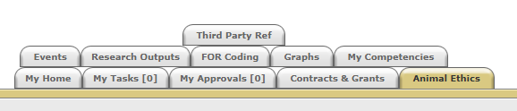

- Click on the “Animal Ethics” tab:

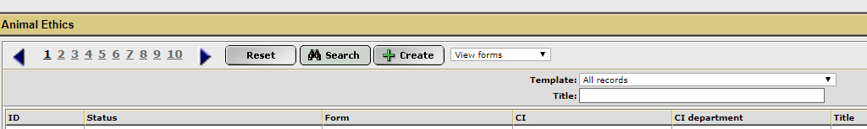
- Ensure the drop-down option is showing as “View Forms”, and click the “Create” button to create a new coversheet:

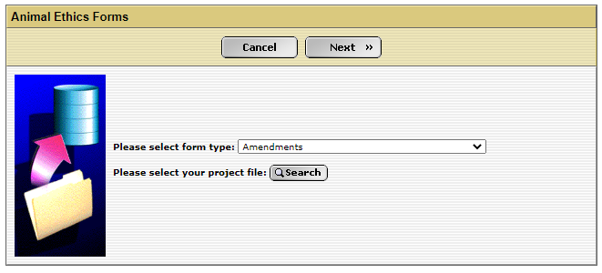
- Select the Amendment coversheet from the drop-down list (shown below), link the coversheet to the relevant project by clicking the “Search” button, and then click “Next”:

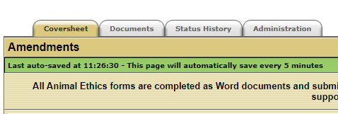
- A new screen will appear (see below). Click on the weblink and download the “Amendments” form.

- When this form is complete, save the document to your computer and upload a copy into the IRMA coversheet. Click on the “Documents” tab (shown in 5. picture) and upload the form by clicking the “+ Add” button. Ensure each attachment is clearly labelled when uploading.

- Once this form has been uploaded into IRMA, return to the “Coversheet” tab, and click the “Submit” button.
TASK COMPLETE

