Cadaver and Tissue Notification Form
Animal Ethics Committee
AE
010

Animal Ethics Office
Scientific use of animals undertaken by Murdoch University staff and students must comply with the requirements of the Australian Code for the Care and Use of Animals for Scientific Purposes, 2013 (the Animal Code) and the Animal Welfare Act, 2002 (WA). Persons using animals for scientific purposes must consider the 3 Rs: Replacement, Reduction, and Refinement at all times.

Responses to ALL questions must be provided on this form. Applicants should not simply refer to an attachment without summarising relevant material on this form.
(08) 9360 7366
animal.ethics@murdoch.edu.au

All applications are to be submitted in the IRMA system as attachments to a coversheet.

Project Title:
Part A - |  | Personnel information
1.1 | Chief Investigator / Supervisor:  A Murdoch University internal staff member with ultimate responsibility for the project
 | Title |  |  | Given Name | Surname
 | College
 | Contact Address
 | Telephone No. |  |  |  | Email
1.2 | Co-Investigator 1:
 | Title |  |  | Given Name | Surname
 | College
 | Contact Address
 | Telephone No. |  |  |  | Email
 | Co-Investigator 2:
 | Title |  |  | Given Name | Surname
 | College
 | Contact Address
 | Telephone No. |  |  |  | Email
 | Co-Investigator 3:
 | Title |  |  | Given Name | Surname
 | College
 | Contact Address
 | Telephone No. |  |  |  | Email
 | Co-Investigator 4:
 | Title |  |  | Given Name | Surname
 | College
 | Contact Address
 | Telephone No. |  |  |  | Email
If there are more than 4 Co-Investigators, complete the “Additional Co-Investigator” form,
and attach in the DOCUMENTS tab in IRMA.
1.3 | List the responsibilities of the Chief and Co-Investigators as they relate to this project.
 |  |  | Responsibilities
 | CI
 | Co-I 1
 | Co-I 2
 | Co-I 3
 | Co-I 4
Part B - |  | Project Details
2.1 | Have the cadavers or tissues been collected for another project with ethics approval? If yes, provide details including title and ethics approval number.
2.2 | Have the tissue / samples been collected specifically for your project? If yes, you may require a full animal ethics application.
2.3 | From which species will you be obtaining cadaver, organs, tissues or samples and how many will be required?
2.4 | Where will the cadavers / tissues be sourced from? How have they become available for your teaching / research?
2.5 | Briefly summarise what will be done with the cadaver, or tissues, or samples obtained.
2.6 | Will any of the material be stored beyond this use? If yes, describe where and how it will be stored.
2.7 | Will any of the material be re-used or be made available for use by others?
Part C - |  | Legislative and Regulatory Controls
3.1 | Permits, Laws and Regulations
 | Is the acquisition, retention or use of cadavers, tissues or samples in this project, subject to any permit, law or regulation of the State or Commonwealth, e.g. Reg 23 permit? If yes, provide details.
3.2 | Potential conflict/s of Interest
 | Do you have any actual or potential interest, including any financial interest or other relationship or affiliation that may affect judgements and decisions regarding the wellbeing of the animals involved? If yes, provide details.

for Animal Ethics forms
010
AE
Submission Information

How to submit this form:
013

All forms are received and processed through the IRMA system. To do this, you will need to create a “Coversheet” in IRMA and attach this form and any supporting documents as part your submission.

- Begin by creating a Coversheet. Log into IRMA and click on “Researcher Profile” (found in the top right-hand corner of your screen). If you do not have IRMA access, contact IT through ServiceNow.

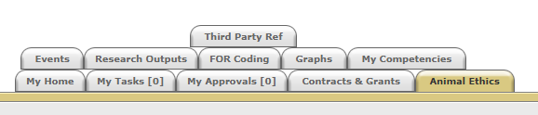

- Click on the “Animal Ethics” tab:

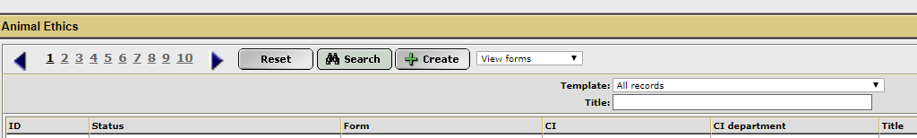
- Ensure the drop-down option is showing as “View Forms”, and click the “Create” button to create a new coversheet:

- Select the Cadaver and Tissue Usage Notification coversheet template from the drop-down list (shown below), and then click “Next”:
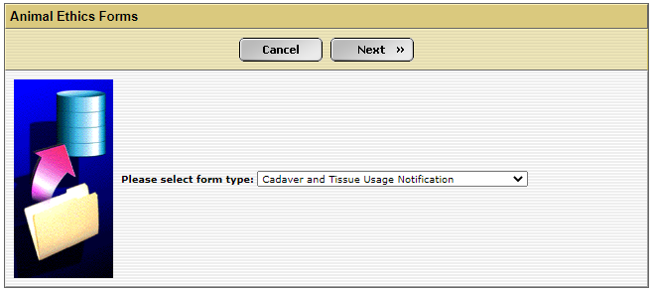

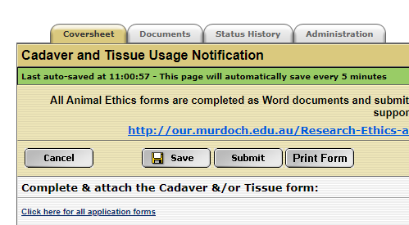
- A new screen will appear (see below). Complete the first tab, “Coversheet” to provide the researcher and project information. Click on the weblink and download the “Cadaver and Tissue Usage Notification” form.

- When this form is complete, save the document to your computer and upload a copy into the IRMA coversheet. Click on the “Documents” tab (shown in 5. picture) and upload the form by clicking the “+ Add” button. Include any other supporting documentation, e.g. monitoring sheets, owner consent forms, SOPs, etc., in the “Documents” tab. Ensure each attachment is clearly labelled when uploading.

- Once this form has been uploaded into IRMA, return to the “Coversheet” tab and click the “Submit” button (as shown in pic in 5.).

TASK COMPLETE

