029
AE
Change of Chief Investigator Form
(Major Amendment)
Animal Ethics Committee
Scientific use of animals undertaken by Murdoch University staff and students must comply with the requirements of the Australian Code for the Care and Use of Animals for Scientific Purposes, 2013 (the Animal Code) and the Animal Welfare Act, 2002 (WA). Persons using animals for scientific purposes must consider the 3 R’s: Replacement, Reduction, and Refinement at all times.

Responses to ALL questions must be provided on this form.
Animal Ethics Office
(08) 9360 7366
animal.ethics@murdoch.edu.au
All forms are to be submitted in the IRMA system as attachments to a coversheet.

Part A - |  | Current Permit information
 | Permit Number (*****/**): |  |  |  |  |  |  |  |  | Protocol ID (***):
 | Project Title:
 | Current Chief Investigator:
 | Title |  |  | Given Name |  |  | Surname
 | Form Completed by:
 | Role on the project:
Part B - |  | Change of Chief Investigator
The Chief Investigator for a project must be a Murdoch University staff member who is able to take ultimate responsibility for the project.

This person must ensure that everyone involved in the project understand and accept their responsibilities; ensure that procedures and resources are in place so that everyone involved in the care and use of animals in the project can meet their responsibilities, including their education, training, and supervision; and be competent with respect to the wellbeing of animals used in the project.

A change of Chief Investigator is considered a major amendment to a protocol and will be reviewed at an AEC meeting.

Work cannot commence until notification of approval for Change of Chief Investigator is received.

2.1 | Title |  | Given Name |  |  | Surname
 | College
 | Contact Address
 | Telephone No. |  |  |  |  | Email
 | Has the new Chief Investigator completed ComPass Training? |  |  |  |  |  |  |  |  |  | Yes No
 | What are the new Chief Investigator’s qualifications, training, and experience relevant to this project?
 | What are the new Chief Investigator’s responsibilities as they relate to this project?
 | Will the previous Chief Investigator remain on the protocol as a co-investigator? |  |  |  |  |  |  |  |  |  | Yes No
 | Provide details for the reason for the change in Chief Investigator.
 | The Chief Investigator of each permit is nominated by default to complete the annual reporting requirements. Please advise if you wish to nominate an alternative co-investigator for this role.
Part C - |  | Declaration
3.1 | In accepting responsibility as Chief Investigator, I declare that:
 | - I accept personal responsibility to ensure that all animals in this project will receive humane and proper treatment in accordance with the Australian Code for the Care and Use of Animals for Scientific Purposes 2018, the Animal Welfare Act, 2002 (WA), and in accordance with the approved ethics application and any AEC conditions imposed by Murdoch University Animal Ethics Committee (AEC);
 | - I will ensure that written approval from the AEC is obtained before commencing on the project or before making changes to the project (e.g., changes of personnel, methods or animal numbers as described in the approved project);
 | - I will continue to seek alternative methods which do not involve the use of living animals, or which enable comparable results to be achieved using fewer animals
 | - All investigators involved are fully informed about the project and its ethical issues and impacts;
 | - Procedures and adequate resources are in place so that all people involved in the care and use of animals in the project can meet their responsibilities, including their education, training, and supervision, as appropriate; and
 | - I accept responsibility for promptly notifying the AEC of any adverse events, unexpected deaths, or euthanasia.
 | New Chief Investigator - Enter full name |  |  |  |  |  |  |  |  | Date:

009
AE
Submission Information
for Animal Ethics forms
How to submit this form:
013

All forms are received and processed through the IRMA system. To do this, you will need to create a “Coversheet” in IRMA and attach this form and any supporting documents as part your submission.

- Begin by creating a Coversheet. Log into IRMA and click on “Researcher Profile” (found in the top right-hand corner of your screen). If you do not have IRMA access, lodge a request with IT through ServiceNow.

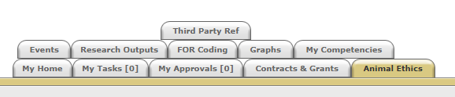

- Click on the “Animal Ethics” tab:

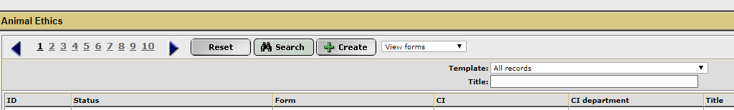
- Ensure the drop-down option is showing as “View Forms”, and click the “Create” button to create a new coversheet:

- Select the Change of Chief Investigator coversheet from the drop-down list (shown below), link the coversheet to the relevant project by clicking the “Search” button, and then click “Next”:
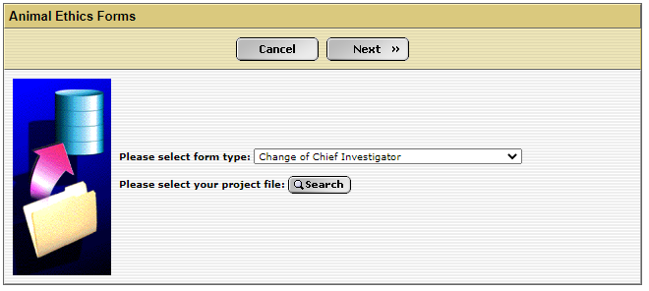

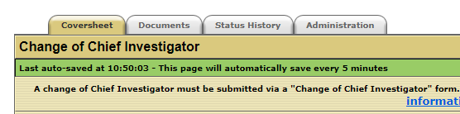
- A new screen will appear (see below). Click on the weblink and download the “Change of Chief Investigator” form.

- When this form is complete, save the document to your computer and upload a copy into the IRMA coversheet. Click on the “Documents” tab (shown in 5. picture) and upload the form by clicking the “+ Add” button. Ensure each attachment is clearly labelled when uploading.

- Once this form has been uploaded into IRMA, return to the “Coversheet” tab, and click the “Submit” button.
TASK COMPLETE

