Animal Ethics Committee
AE
030
Change of Co-Investigator Form
Scientific use of animals undertaken by Murdoch University staff and students must comply with the requirements of the Australian Code for the Care and Use of Animals for Scientific Purposes, 2013 (the Animal Code) and the Animal Welfare Act, 2002 (WA). Persons using animals for scientific purposes must consider the 3 R’s: Replacement, Reduction, and Refinement at all times.

Responses to ALL questions must be provided on this form.
Animal Ethics Office
(08) 9360 7366
animal.ethics@murdoch.edu.au
All forms are to be submitted in the IRMA system as attachments to a coversheet.

Part A - |  |  | Current Permit information
 | Permit Number (*****/**): |  |  |  |  |  |  |  |  |  |  |  | Protocol ID (***):
 | Project Title:
 | Chief Investigator:
 | Title |  |  |  |  |  | Given Name |  |  |  |  | Surname
 | Form Completed by:
 | Role on the project:
Part B - |  |  | Changes to Co-Investigators
3.1 |  | If removing Co-Investigators, complete the following:
 |  | Title | Full Name |  |  |  |  |  |  | Role on Project
1
2
3
4
5
6
7
8
3.2 |  | If adding new Co-Investigators, complete the following:
 |  | Co-Investigator 1:
 |  | Title |  |  |  | Given Name |  |  |  |  | Surname
 |  | College
 |  | Contact Address
 |  | Telephone No. |  |  |  |  |  |  |  |  | Email
 |  | Has the new Co-Investigator completed ComPass Training? |  |  |  |  |  |  |  |  |  |  |  |  |  |  |  |  | Yes No
 |  | Co-Investigator 2:
 |  | Title |  |  |  | Given Name |  |  |  |  | Surname
 |  | College
 |  | Contact Address
 |  | Telephone No. |  |  |  |  |  |  |  |  | Email
 |  | Has the new Co-Investigator completed ComPass Training? |  |  |  |  |  |  |  |  |  |  |  |  |  |  |  |  | Yes No
 |  | Co-Investigator 3:
 |  | Title |  |  |  | Given Name |  |  |  |  | Surname
 |  | College
 |  | Contact Address
 |  | Telephone No. |  |  |  |  |  |  |  |  | Email
 |  | Has the new Co-Investigator completed ComPass Training? |  |  |  |  |  |  |  |  |  |  |  |  |  |  |  |  | Yes No
 |  | Co-Investigator 4:
 |  | Title |  |  |  | Given Name |  |  |  |  | Surname
 |  | College
 |  | Contact Address
 |  | Telephone No. |  |  |  |  |  |  |  |  | Email
 |  | Has the new Co-Investigator completed ComPass Training? |  |  |  |  |  |  |  |  |  |  |  |  |  |  |  |  | Yes No
3.3 |  | List the responsibilities of the new Co-Investigators as they relate to this project.
 |  |  |  | Responsibilities
 |  | Co-I 1
 |  | Co-I 2
 |  | Co-I 3
 |  | Co-I 4
3.4 |  | List qualifications, training, and experience and how they relate to responsibilities for each new  Co-investigator.  Briefly summarise how they are appropriate to the procedures to be performed and species to be used.
 |  |  |  | Qualifications, training, experience relevant to this project:
 |  | Co-I 1
 |  | Co-I 2
 |  | Co-I 3
 |  | Co-I 4
Part C - |  |  |  |  | Declaration for new Co-Investigators
3.1 | In accepting responsibility as Co-Investigator, I declare that:
 | - I accept personal responsibility to ensure that all animals in this project will receive humane and proper treatment in accordance with the Australian Code for the Care and Use of Animals for Scientific Purposes, 2018, the Animal Welfare Act, 2002 (WA), and in accordance with the approved ethics application and any AEC conditions imposed by Murdoch University Animal Ethics Committee (AEC);
 | - I will ensure that written approval from the AEC is obtained before commencing on the project or before making changes to the project (e.g., changes of personnel, methods or animal numbers as described in the approved project);
 | - I will continue to seek alternative methods which do not involve the use of living animals, or which enable comparable results to be achieved using fewer animals
 | - All investigators involved are fully informed about the project and its ethical issues and impacts;
 | - Procedures and adequate resources are in place so that all people involved in the care and use of animals in the project can meet their responsibilities, including their education, training, and supervision, as appropriate; and
 | - I accept responsibility for promptly notifying the AEC of any adverse events, unexpected deaths, or euthanasia.
 | Co-Investigator 1: Enter full name |  |  |  |  |  |  |  |  |  |  |  |  |  |  | Date:
 | Co-Investigator 2: Enter full name |  |  |  |  |  |  |  |  |  |  |  |  |  |  | Date:
 | Co-Investigator 3: Enter full name |  |  |  |  |  |  |  |  |  |  |  |  |  |  | Date:
 | Co-Investigator 4: Enter full name |  |  |  |  |  |  |  |  |  |  |  |  |  |  | Date:

Animal Ethics Committee
External Investigators Approval Form
011
AE

External Investigators Approval Form

(Print off and ask any external researchers to complete and return)

Protocol ID.: ___________________________________________
Permit No.: ___________________________________________
Protocol Title: ___________________________________________
___________________________________________
Chief Investigator: ___________________________________________

Name of External Investigator: ___________________________________________
Institution: ___________________________________________
Job / Position at Institution: ___________________________________________
Email contact: ___________________________________________
Telephone contact: ___________________________________________

DECLARATION OF RESEARCHER

By signing below, you agree to the following:

1. I confirm that I will conduct the research in accordance with the protocol as approved by the Murdoch University Animal Ethics Committee (AEC) and in compliance with the Animal Research Act (1985 – Animal Research Regulation 2010), the 8th Edition of the Australian code for the care and use of animals for scientific purposes (NHMRC, 2013) and the Australian code for the responsible conduct of research (NHMRC 2007).

2. I confirm that as an external investigator, I have informed my organisation’s AEC about this collaborative research, and I am aware that, depending on my organisation’s policies, I may be required to submit an application to my AEC. Please refer to Section 2.4.9 of the Australian code for the care and use of animals for scientific purposes 8th Edition.

____________________________ ___________________________ ______________________
(Name) (Signature) (Date)

Once complete, please return to the Chief Investigator to include with this notification form.

for Animal Ethics forms
AE
009
Submission Information
How to submit this form:
013

All forms are received and processed through the IRMA system. To do this, you will need to create a “Coversheet” in IRMA and attach this form and any supporting documents as part your submission.

- Begin by creating a Coversheet. Log into IRMA and click on “Researcher Profile” (found in the top right-hand corner of your screen). If you do not have IRMA access, lodge a request with IT through ServiceNow.

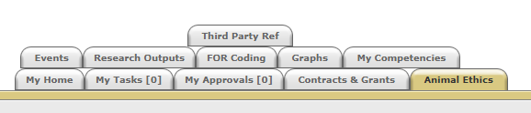

- Click on the “Animal Ethics” tab:

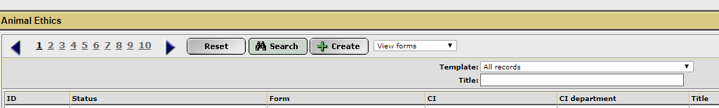
- Ensure the drop-down option is showing as “View Forms”, and click the “Create” button to create a new coversheet:

- Select the Changes to Co-Investigator team coversheet template from the drop-down list (shown below), link the coversheet to the relevant project by clicking the “Search” button, and then click “Next”:
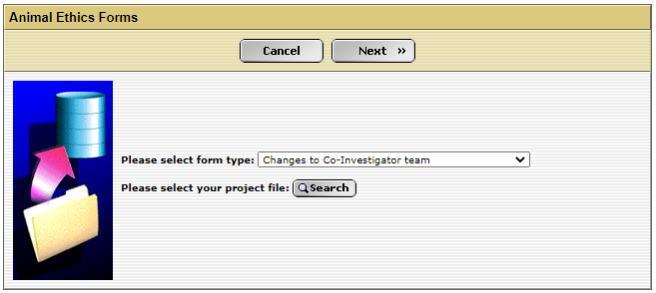

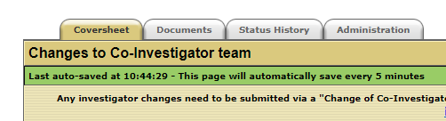
- A new screen will appear (see below). Click on the weblink to access the Change of Co-Investigator form.

- When this form is complete, save the document to your computer and upload a copy into the IRMA coversheet. Click on the “Documents” tab (shown in 5. picture) and upload the form by clicking the “+ Add” button. Ensure each attachment is clearly labelled when uploading.

- Once this form has been uploaded into IRMA, return to the “Coversheet” tab, and click the “Submit” button.
TASK COMPLETE

