AE
005
Animal Ethics Committee
Observation Application Form
Scientific use of animals undertaken by Murdoch University staff and students must comply with the requirements of the Australian Code for the Care and Use of Animals for Scientific Purposes, 2013 (the Animal Code) and the Animal Welfare Act, 2002 (WA). Persons using animals for scientific purposes must consider the 3 R’s: Replacement, Reduction, and Refinement at all times.

Responses to ALL questions must be provided on this form. Applicants should not simply refer to an attachment without summarising relevant material on this form.
Animal Ethics Office
(08) 9360 7366
animal.ethics@murdoch.edu.au
All applications are to be submitted in the IRMA system as attachments to a coversheet.

Project Title: |  |  |  |  |  |  |  |  |  |  |  |  |  |  | Office Use Only:
 |  |  |  |  |  |  |  |  |  |  |  |  |  |  | Permit No: |  |  |  |  |  |  | O
 |  |  |  |  |  |  |  |  |  |  |  |  |  |  | Submission Date:
Part A - |  | Personnel information
1.1 | Chief Investigator / Supervisor:  A Murdoch University internal staff member with ultimate responsibility for the project  If you are not an internal Murdoch University staff member e.g., Adjunct, external applicant, contact the Animal Ethics Office for further information.
 | Title |  |  |  | Given Name |  |  |  |  |  | Surname
 | School
 | Contact Address
 | Telephone No. |  |  |  |  |  |  |  |  |  | Email
1.2 | Co-Investigator 1:
 | Title |  |  |  | Given Name |  |  |  |  |  | Surname
 | School
 | Contact Address
 | Telephone No. |  |  |  |  |  |  |  |  |  | Email
 | Co-Investigator 2:
 | Title |  |  |  | Given Name |  |  |  |  |  | Surname
 | School
 | Contact Address
 | Telephone No. |  |  |  |  |  |  |  |  |  | Email
 | Co-Investigator 3:
 | Title |  |  |  | Given Name |  |  |  |  |  | Surname
 | School
 | Contact Address
 | Telephone No. |  |  |  |  |  |  |  |  |  | Email
 | Co-Investigator 4:
 | Title |  |  |  | Given Name |  |  |  |  |  | Surname
 | School
 | Contact Address
 | Telephone No. |  |  |  |  |  |  |  |  |  | Email
 | If there are more than 4 Co-Investigators, complete the “Additional Co-Investigator” form and attach in the DOCUMENTS tab in IRMA.
1.3 | List the responsibilities of the Chief and Co-Investigators as they relate to this project.
 |  |  |  | Responsibilities
 | CI
 | Co-I 1
 | Co-I 2
 | Co-I 3
 | Co-I 4
1.4 | List qualifications, training and experience and how they relate to responsibilities for each investigator.  Briefly summarise how they are appropriate to the procedures to be performed and species to be used.
 |  |  |  | Qualifications, training, experience |  |  |  |  |  |  |  |  | Application to procedure
 | CI
 | Co-I 1
 | Co-I 2
 | Co-I 3
 | Co-I 4
1.6 | Specific responsibilities
 | Although some investigators have specific responsibilities, all investigators have personal responsibility for all matters that relate to the wellbeing of animals that they use for the duration of the approved period until provisions are made for the animal at the conclusion of their use.
Primary Contact
Provide the name of the investigator who oversees the day-to-day aspects of the project. This need not be the Chief Investigator.
Emergency Contact
Provide the name of the investigator who can be contacted in an emergency.
Nominated Person
Who will be responsible for completing the annual reports and providing the yearly animal usage numbers?
1.7 | Resources
 | (i) |  | Is this project externally funded? |  |  |  |  |  |  |  |  |  |  |  |  |  |  |  |  | Yes No
 |  |  | If yes, indicate source of funds.
 | (ii) |  | If external funding is not obtained, will the project still proceed? |  |  |  |  |  |  |  |  |  |  |  |  |  |  |  |  | Yes No
 | (iii) |  | If the project will proceed without external funding, are adequate resources available for the conduct of the project e.g. repeat field visits, etc.? |  |  |  |  |  |  |  |  |  |  |  |  |  |  |  |  | Yes No
1.8 | Is this project a continuation of a previously approved Murdoch University AEC project? |  |  |  |  |  |  |  |  |  |  |  |  |  |  |  |  |  |  | Yes No
 | If yes, provide AEC permit number.
1.9 | Collaborative project
 | (i) |  | Is this a collaborative project between Murdoch University and another institution? |  |  |  |  |  |  |  |  |  |  |  |  |  |  |  |  | Yes No
 |  |  | If yes, state the name and location of institution/s.
 | (ii) |  | Provide the name of the main contact/s for the other institution/s.
 | (iii) |  | Will Murdoch AEC have overarching responsibility for the project approval? |  |  |  |  |  |  |  |  |  |  |  |  |  |  |  |  | Yes No
Part B - |  | Justification  In this section, provide an overview of the project, its aims, design and intended outcomes. It is important to use plain English to ensure that all AEC members understand the proposed project.
2.1 | Keywords
 | Provide a list of and definitions for any technical terms and acronyms to assist the AEC to understand this application:
 | Term |  |  |  |  |  | Lay Explanation
2.2 | Provide a brief plain English description of the hypothesis, aims of this project, the proposed research design and methods, and the projected outcomes.
 | HYPOTHESIS
AIMS
The aims may include an outline of how this project relates to an overall program of work/ the bigger research picture. Provide any useful information or context to this project including peer-reviewed literature, where possible. (Max one page)

RESEARCH DESIGN/METHOD
Provide an overview of how the project is designed in relation to its aims. This may include the steps taken to consider and apply the 3Rs and a brief explanation why the particular species, strain or breed was chosen. (Max one page)

PROJECTED OUTCOMES
Include the projected benefits to humans, animals or the environment, and how these benefits support the proposed use of animals. (Max one page)

2.3 | Originality
 | Is this a repetition of any previously performed study? i.e. has this study previously been undertaken anywhere in the world, in Australia or at Murdoch? |  |  |  |  |  |  |  |  |  |  |  |  |  |  |  |  |  | Yes No
If yes, briefly describe the previous work and justify why this needs to be repeated.
If no, how has this been determined?

Part C - |  | Animal Wellbeing and Refinement  In this section, identify and justify the impact of all aspects of the project on the animal’s well-being from the time it is obtained until the project is completed. At each step, provide information about how impacts on the animals will be minimised.
3.1 | Harm or potential harm to the animal
 | Identify any potential harm/s to the animal that may arise from observations being performed, including harm or distress. Identify how harms will be mitigated.
3.2 | Animal Use
 |  |  |  |  |  |  |  |  |  | Animal Numbers
 | Species / Strain & Common Name |  |  |  |  |  |  |  | Target or Bycatch? | Yr 1 |  | Yr 2 |  |  |  | Yr 3 |  |  |  |  |  |  | Total
If more than 10 species or strains of animals will be used in this project, attach a separate table in the DOCUMENTS tab in IRMA.
Ensure that you have stated your rationale for the choice of animal in Project Details.
3.3 | Provide details of the location/s where observations will be conducted. For locations that are remote or not readily identifiable to the layperson, provide details of the closest town or identifiable location.
3.4 | Rare or Endangered Species
 | Are any of the target species classified as rare or endangered? |  |  |  |  |  |  |  |  |  |  |  |  |  |  |  |  |  | Yes No
 | If yes, specify which standard you have used (e.g. IUNC, DEC) and justify the use of the animals. Is there a related, alternative species suitable for the project? Animals from an endangered species must not be used unless the research is of direct benefit to the conservation of that species and will not further endanger the target species.
Part D - |  | Replacement  In this section, explain what alternatives you have considered and why animals are needed for the project.
4.1 | Have you considered potential alternatives to animals for all, or parts, of this project? |  |  |  |  |  |  |  |  |  |  |  |  |  |  |  |  |  | Yes No
If yes, provide details of the alternatives implemented or why alternatives were not suitable.
If no, justify the need for the use of animals in this project.

4.2 | Will the results of this project assist in developing techniques that do not require the use of animals? |  |  |  |  |  |  |  |  |  |  |  |  |  |  |  |  |  | Yes No
 | If yes, specify below.
4.3 | Will the results of this project assist to reduce numbers of animals for future projects? |  |  |  |  |  |  |  |  |  |  |  |  |  |  |  |  |  | Yes No
 | If yes, specify below.
Part E - |  | Reduction  In this section, provide information about the number of animals, the species and strain, the reasons why this number is necessary, whether there is an opportunity for sharing tissues or animals and strategies you have utilised to minimise the overall number of animals you plan to use.
5.1 | Justification  Provide a justification for the use of animals.
 |  |  |  |  |  |  |  |  |  |  |  |  |  |  |  |  | Tick all that apply
 | (i) |  | Significant understanding of human and / or animal biology
 | (ii) |  | Maintenance and improvement of human and / or animal health and welfare
 | (iii) |  | Achievement of educational objectives
 | (iv) |  | Improvement of animal management or production
 | (v) |  | Understanding, maintenance and improvement of the natural environment
5.2 | What strategies are in place to ensure that only the minimum number of animals necessary for this project will be used?
Part F - |  | Monitoring and Fate of animals
6.1 | In the event that injured wildlife are observed during the course of the study, describe what action will be taken. For non-veterinarians, please contact Wildcare Helpline on (08) 9474 9055.
6.2 | Other ethical considerations
 | Are there any other features of your proposal, which raise other ethical considerations such as a requirement for human ethics approval? |  |  |  |  |  |  |  |  |  |  |  |  |  |  |  |  |  | Yes No
 | If yes, provide details.
Part G - |  | Legislative and Regulatory Controls
7.1 | Permits, Laws and Regulations
 | Is the acquisition, retention or use of animals in this project, subject to any permit, law or regulation of the State or Commonwealth, e.g. Reg 17 permit? |  |  |  |  |  |  |  |  |  |  |  |  |  |  |  |  |  | Yes No
 | If yes, provide details.
7.2 | Potential conflict/s of Interest
 | Do you have any actual or potential interest, including any financial interest or other relationship or affiliation that may affect judgements and decisions regarding the wellbeing of the animals involved? |  |  |  |  |  |  |  |  |  |  |  |  |  |  |  |  |  | Yes No
 | If yes, provide details.
7.3 | Health and Safety Concerns
 | (i) |  | Will you comply with all requirements of the Murdoch Fieldwork Safety and Health Policy? |  |  |  |  |  |  |  |  |  |  |  |  |  |  | Yes No

AE
011
External Investigators Approval Form
Animal Ethics Committee

New Application
External Investigators Approval Form

(Print off and ask any external researchers to complete and return)

Protocol ID.: ___________________________________________
Permit No.: ___________________________________________
Protocol Title: ___________________________________________
___________________________________________
Chief Investigator: ___________________________________________

Name of External Investigator: ___________________________________________
Institution: ___________________________________________
Job / Position at Institution: ___________________________________________
Email contact: ___________________________________________
Telephone contact: ___________________________________________

DECLARATION OF RESEARCHER

By signing below, you agree to the following:

1. I confirm that I will conduct the research in accordance with the protocol as approved by the Murdoch University Animal Ethics Committee (AEC) and in compliance with the Animal Research Act (1985 – Animal Research Regulation 2010), the 8th Edition of the Australian code for the care and use of animals for scientific purposes (NHMRC, 2013) and the Australian code for the responsible conduct of research (NHMRC 2007).

2. I confirm that as an external investigator, I have informed my organisation’s AEC about this collaborative research, and I am are aware that, depending on my organisation’s policies, I may be required to submit an application to my AEC. Please refer to Section 2.4.9 of the Australian code for the care and use of animals for scientific purposes 8th Edition.

____________________________ ___________________________ ______________________
(Name) (Signature) (Date)

Once complete, please return to the Animal Ethics Office via email to animal.ethics@murdoch.edu.au.

Submission Information
for Animal Ethics forms
AE
013

How to submit this form:

All Animal Ethics forms are received and processed through the IRMA system. To do this, you will need to create a “Coversheet” in IRMA and attach this form and any supporting documents as part your submission.

- Begin by creating a Coversheet. Log into IRMA and click on “Researcher Profile” (found in the top right-hand corner of your screen). If you do not have IRMA access, lodge a request with IT through ServiceNow

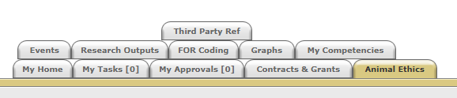
- Click on the “Animal Ethics” tab:

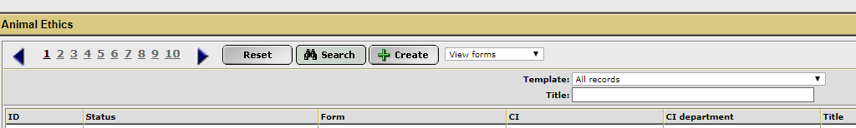
- Ensure the drop-down option is showing as “View Forms”, and click the “Create” button to create a new coversheet:

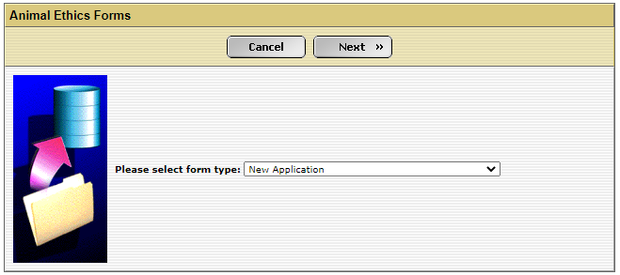
- Select the New Application coversheet template from the drop-down list (shown below) and then click “Next”:

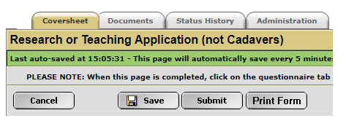
- A new screen will appear (see below). Complete the first tab, called “Coversheet”, to provide the researcher and project information. Click on the weblink and download the “Observation Application” form.

- When this form is complete, save the document to your computer and upload a copy into the IRMA coversheet. Click on the “Documents” tab (shown in 5. picture) and upload the form by clicking the “+ Add” button. Include any other supporting documentation, e.g. monitoring sheets, owner consent forms, SOPs, etc., in the “Documents” tab. Ensure each attachment is clearly labelled when uploading.

- Once this form has been uploaded into IRMA, return to the “Coversheet” tab and click the “Submit” button (as shown in pic in 5.).

TASK COMPLETE

