006
AE
Animal Ethics Committee
Reciprocal Application Form
Scientific use of animals undertaken by Murdoch University staff and students must comply with the requirements of the Australian Code for the Care and Use of Animals for Scientific Purposes, 2013 (the Animal Code) and the Animal Welfare Act, 2002 (WA). Persons using animals for scientific purposes must consider the 3 R’s: Replacement, Reduction, and Refinement at all times.

This form is to be used when a Murdoch University staff or student is involved in a project approved by another institution’s Ethics Committee.
Animal Ethics Office
(08) 9360 7366
animal.ethics@murdoch.edu.au
All applications are to be submitted in the IRMA system as attachments to a coversheet.

Project Title: |  |  |  |  |  |  |  |  | Office Use Only:
 |  |  |  |  |  |  |  |  | Permit No: |  |  |  | N
 |  |  |  |  |  |  |  |  | Submission Date:
Part A - |  | Collaborative Project Information
1.1 | Is this a collaborative project between Murdoch University and another institution? |  |  |  |  |  |  |  |  |  |  | Yes No
 | If yes, state the name and location of the institution/s.
1.2 | Provide the name of the main contact/s for the other institution/s:
 | Title |  |  |  | Given Name | Surname
 | School
 | Contact Address
 | Telephone No. |  |  |  |  | Email
1.3 | State how the facilities of the other institution/s will be used.
Part B - |  | Murdoch University Personnel information
2.1 | Murdoch Investigator 1:
 | Title |  |  |  | Given Name | Surname
 | School
 | Telephone No. |  |  |  |  | Email
 | Murdoch Investigator 2:
 | Title |  |  |  | Given Name | Surname
 | School
 | Telephone No. |  |  |  |  | Email
 | Murdoch Investigator 3:
 | Title |  |  |  | Given Name | Surname
 | School
 | Telephone No. |  |  |  |  | Email
 | Murdoch Investigator 4:
 | Title |  |  |  | Given Name | Surname
 | School
 | Telephone No. |  |  |  |  | Email
If there are more than 4 Co-Investigators, complete the “Additional Co-Investigator” form,
and attach in the DOCUMENTS tab in IRMA.
2.2 | List the responsibilities of the Murdoch Investigators as they relate to this project.
 |  |  |  | Responsibilities
 | CI
 | Co-I 1
 | Co-I 2
 | Co-I 3
 | Co-I 4
2.3 | List qualifications, training and experience and how they relate to responsibilities for each Murdoch investigator.  Briefly summarise how they are appropriate to the procedures to be performed and species to be used.
 |  |  |  | Qualifications, training, experience |  |  | Application to procedure
 | CI
 | Co-I 1
 | Co-I 2
 | Co-I 3
 | Co-I 4
2.4 | Identify any training needs and indicate how these will be provided.
2.5 | Location.  Where will this project be conducted?
Part C - |  | Legislative and Regulatory Controls
3.1 | Permits, Laws and Regulations
 | Is the acquisition, retention or use of animals in this project, subject to any permit, law or regulation of the State or Commonwealth, e.g. Reg 17 permit? |  |  |  |  |  |  |  |  |  | Yes No
3.2 | Potential conflict/s of Interest
 | Do you have any actual or potential interest, including any financial interest or other relationship or affiliation that may affect judgements and decisions regarding the wellbeing of the animals involved? |  |  |  |  |  |  |  |  |  | Yes No
 | If yes, provide details.
Part D - |  | Submission Checklist
 | Ensure you include the following with your submission: |  |  |  |  |  |  |  |  | Attached:
 | (i) |  | Ethics application submitted to the other institution’s AEC
 | (ii) |  | Any application supporting documents (i.e. monitoring sheets, etc)
 | (iii) |  | Approval Letter from the other AEC.

for Animal Ethics forms
Submission Information
013
AE

How to submit Animal Ethics forms in IRMA:

All forms are received and processed through the IRMA system. To do this, you will need to create a “Coversheet” in IRMA and attach this form and any supporting documents as part your submission.

- Begin by creating a Coversheet. Log into IRMA and click on “Researcher Profile” (found in the top right-hand corner of your screen). If you do not have IRMA access, lodge a request with IT through ServiceNow.

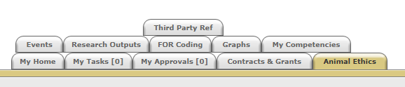

- Click on the “Animal Ethics” tab:

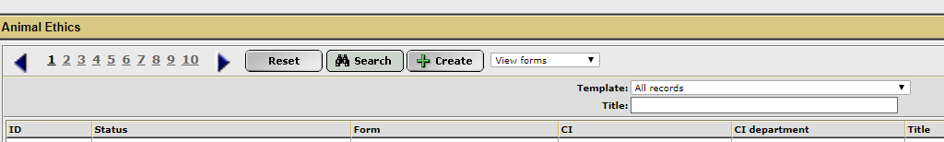
- Ensure the drop-down option is showing as “View Forms”, and click the “Create” button to create a new coversheet:

- Select the Reciprocal coversheet template from the drop-down list (shown below), and then click “Next”:
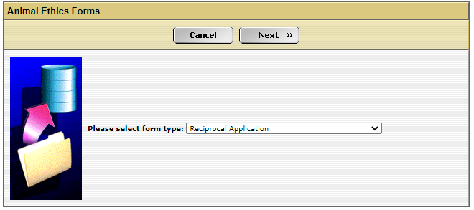

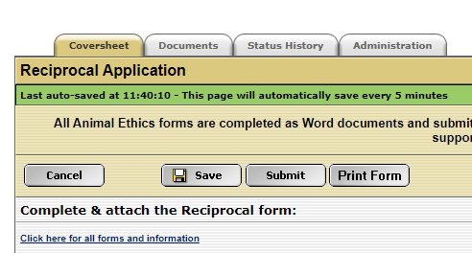
- A new screen will appear (see below). Complete the first tab, called “Coversheet”, to provide the researcher and project information. Click on the weblink and download the “Reciprocal Application” form.

- When the form has been downloaded and completed, save the document to your computer, and upload a copy into the IRMA coversheet you have just created. Click on the “Documents” tab and upload the form by clicking the “+ Add” button.

Include any other supporting documentation, e.g. monitoring sheets, owner consent forms, SOPs, references, etc., in the “Documents” tab. Ensure each attachment is clearly labelled in the “Document Description” box.

- Once this form, and all other supporting documentation, have been uploaded into IRMA, return to the “Coversheet” tab and click the “Submit” button.

TASK COMPLETE

