s

012

AE

Animal Ethics Committee

**Additional Co-Investigator Form**



Scientific use of animals undertaken by Murdoch University staff and students must comply with the requirements of the *Australian Code for the Care and Use of Animals for Scientific Purposes, 2013* (the *Animal Code*) and the *Animal Welfare Act, 2002* (WA). Persons using animals for scientific purposes must consider the 3 R’s: **Replacement, Reduction, and Refinement** at all times.

Responses to **ALL** questions must be provided on this form. Applicants should not simply refer to an attachment without summarising relevant material on this form.

**Animal Ethics Office**

(08) 9360 7366

animal.ethics@murdoch.edu.au

All forms are to be submitted in the **IRMA** system as attachments to a coversheet.

|  |  |  |  |  |  |  |  |  |  |
| --- | --- | --- | --- | --- | --- | --- | --- | --- | --- |
|  |  | |  | |  | |  |  | |
| **Other Co-Investigators involved in use of live animals in this unit:** | | | | | | | | | |
|  |  | |  | |  | |  |  | |
|  |  | |  | |  | |  |  | |
| **Title** | **Full Name** | | | **School** | | **Email** | **Telephone** | | |
|  |  | | |  | |  |  | | |
|  |  | | |  | |  |  | | |
|  |  | | |  | |  |  | | |
|  |  | | |  | |  |  | | |
|  |  | | |  | |  |  | | |
|  |  | | |  | |  |  | | |
|  |  | | |  | |  |  | | |
|  |  | | |  | |  |  | | |
|  |  | | |  | |  |  | | |
|  |  | | |  | |  |  | | |
|  | | | | | | | | | |
|  | | | | | | | | | |
|  | | | | | | | | | |
|  | | | | | | | ACE Registered? | | |
| **Role on Project** | | **Relevant Experience** | | | **Qualifications** | | **Yes** | | **No** |
|  | |  | | |  | |  | |  |
|  | |  | | |  | |  | |  |
|  | |  | | |  | |  | |  |
|  | |  | | |  | |  | |  |
|  | |  | | |  | |  | |  |
|  | |  | | |  | |  | |  |
|  | |  | | |  | |  | |  |
|  | |  | | |  | |  | |  |
|  | |  | | |  | |  | |  |
|  | |  | | |  | |  | |  |
|  | | | | | | | | | |

013

AE

**Submission Information**

for Animal Ethics forms

**How to submit this form:**

All Animal Ethics forms are received and processed through the IRMA system. To do this, you will need to create a “**Coversheet**” in IRMA and attach this form and any supporting documents as part your submission.

1. Begin by creating a Coversheet. Log into IRMA and click on “**Researcher Profile**” (found in the top right-hand corner of your screen). If you do not have IRMA access, contact the Animal Ethics IRMA Support Team on (08) 9360 6472 to register.
2. 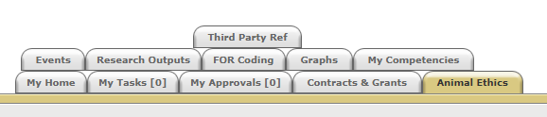Click on the “**Animal Ethics**” tab:
3. 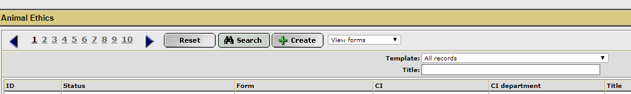Ensure the drop-down option is showing as “**View Forms**”, and click the “**Create**” button to create a new coversheet:
4. Select the coversheet template from the drop-down list (shown below) that is applicable to your submission, and then click “**Next**”:

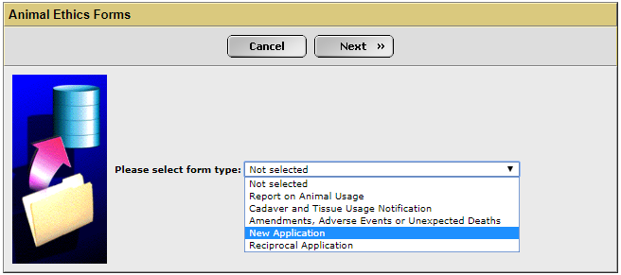

1. 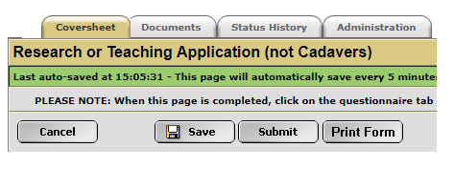A new screen will appear (see below). Complete the first tab, called “**Coversheet**”, to provide the researcher and project information. This is only required for **new applications**. Any amendments or notifications to existing protocols will have this information pre-filled.
2. When this form is complete, save the document to your computer and upload a copy into the IRMA coversheet. Click on the “**Documents**” tab (shown in 5. picture) and upload the form by clicking the “+ **Add**” button. Include any other supporting documentation, e.g. monitoring sheets, owner consent forms, SOPs, etc., in the “**Documents**” tab. Ensure each attachment is clearly labelled when uploading.
3. Once this form has been uploaded into IRMA, return to the “**Coversheet**” tab and click the “**Submit**” button (as shown in pic in 5.).

**TASK COMPLETE**