s
012
AE
Animal Ethics Committee
Additional Co-Investigator Form
Scientific use of animals undertaken by Murdoch University staff and students must comply with the requirements of the Australian Code for the Care and Use of Animals for Scientific Purposes, 2013 (the Animal Code) and the Animal Welfare Act, 2002 (WA). Persons using animals for scientific purposes must consider the 3 R’s: Replacement, Reduction, and Refinement at all times.

Responses to ALL questions must be provided on this form. Applicants should not simply refer to an attachment without summarising relevant material on this form.
Animal Ethics Office
(08) 9360 7366
animal.ethics@murdoch.edu.au
All forms are to be submitted in the IRMA system as attachments to a coversheet.

Other Co-Investigators involved in use of live animals in this unit:
Title | Full Name |  |  | School |  | Email | Telephone
 |  |  |  |  |  |  | ACE Registered?
Role on Project |  | Relevant Experience |  |  | Qualifications |  | Yes |  | No

011
AE
Animal Ethics Committee
External Investigators Approval Form

New Application
External Investigators Approval Form

(Print off and ask any external researchers to complete and return)

Protocol ID.: ___________________________________________
Permit No.: ___________________________________________
Protocol Title: ___________________________________________
___________________________________________
Chief Investigator: ___________________________________________

Name of External Investigator: ___________________________________________
Institution: ___________________________________________
Job / Position at Institution: ___________________________________________
Email contact: ___________________________________________
Telephone contact: ___________________________________________

DECLARATION OF RESEARCHER

By signing below you agree to the following:

1. I apply for approval to conduct the research as outlined in the protocol listed above and confirm that the information in this protocol is accurate.

2. I confirm that I will conduct the research in accordance with the protocol as approved by the Murdoch University Animal Ethics Committee (AEC) and in compliance with the Animal Research Act (1985 – Animal Research Regulation 2010), the 8th Edition of the Australian code for the care and use of animals for scientific purposes (NHMRC, 2013) and the Australian code for the responsible conduct of research (NHMRC 2007).

3. I confirm that all external investigators have informed their organisation’s AEC about this collaborative research and are aware that, depending on their organisation’s policies, they may be required to submit an application alongside the application to the Murdoch University’s AEC. Please refer to Section 2.4.9 of the Australian code for the care and use of animals for scientific purposes 8th Edition.

____________________________ ___________________________ ______________________
(Name) (Signature) (Date)

Once complete, please return to the Animal Ethics Office via email to animal.ethics@murdoch.edu.au.

013
AE
Submission Information
for Animal Ethics forms

How to submit this form:

All Animal Ethics forms are received and processed through the IRMA system. To do this, you will need to create a “Coversheet” in IRMA and attach this form and any supporting documents as part your submission.

- Begin by creating a Coversheet. Log into IRMA and click on “Researcher Profile” (found in the top right-hand corner of your screen). If you do not have IRMA access, contact the Animal Ethics IRMA Support Team on (08) 9360 6472 to register.

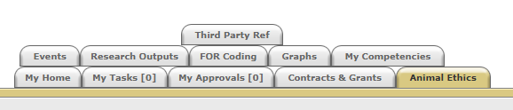
- Click on the “Animal Ethics” tab:

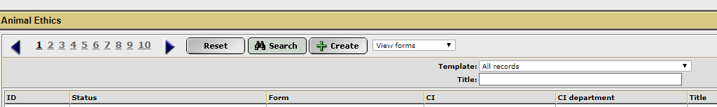
- Ensure the drop-down option is showing as “View Forms”, and click the “Create” button to create a new coversheet:

- Select the coversheet template from the drop-down list (shown below) that is applicable to your submission, and then click “Next”:
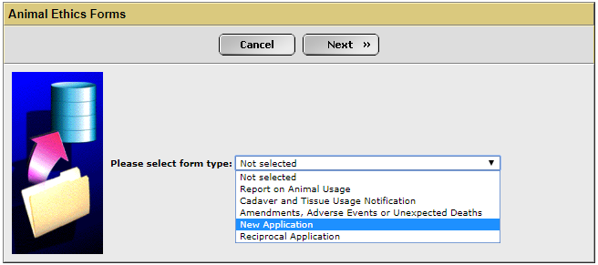

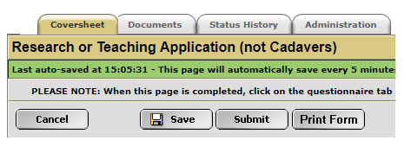
- A new screen will appear (see below). Complete the first tab, called “Coversheet”, to provide the researcher and project information. This is only required for new applications. Any amendments or notifications to existing protocols will have this information pre-filled.

- When this form is complete, save the document to your computer and upload a copy into the IRMA coversheet. Click on the “Documents” tab (shown in 5. picture) and upload the form by clicking the “+ Add” button. Include any other supporting documentation, e.g. monitoring sheets, owner consent forms, SOPs, etc., in the “Documents” tab. Ensure each attachment is clearly labelled when uploading.

- Once this form has been uploaded into IRMA, return to the “Coversheet” tab and click the “Submit” button (as shown in pic in 5.).

TASK COMPLETE

