MyMurdoch Advice

Peer Academic Coaches S2 2024 ( Weeks 1-14 )
 |  | MON |  | TUE |  | WED |  | THU |  | FRI
8:30AM -  11:30AM |  | Khiara  Law + Psychology |  | Steph  Criminology + Forensic Bio. |  | Amira  Health Admin., Policy & Leadership |  | Ronny  Health Admin., Policy & Leadership |  | Cameron  Psychology & Exercise Sci.
9:30AM -  12:30PM |  | Amira  Health Admin., Policy & Leadership |  | Sue  Biomedical Science |  | Sarah  Education |  | Manon  Sustainable Development  Caitlin Wk 1 |  | Seb  Vet
11:30AM -  2:30PM |  | Nick  Exercise Sci. |  | Palden  Community Development |  | Leona  Accounting |  | Sue  Biomedical Science |  | Xavier  Marketing + English
12:30PM -  3:30PM |  | Xavier  Marketing + English |  | Priya  Law + Politics |  | Letitia  Law  Cameron Wk 1-3 |  | Gamu  Nursing |  | Cristina  Biomedical Science
3:30PM -  7:30PM |  | Hannah  Vet |  | Manon  Sustainable Development  Indigo Wk 1 |  | Zoee  Nursing  Caitlin 7-9 |  | Letitia  Law  Gamu Wk 1-3 |  | Jared  Chiropractic
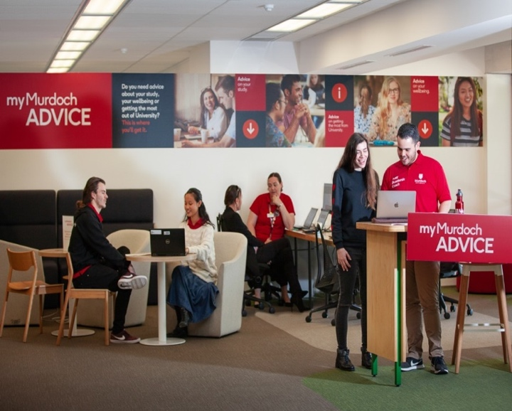
Guide only: Subject to change when PACs are sick, on prac, etc.
Library
Building 350.3.001
MyMurdoch Advice

Peer Academic Coaches S2 2024 ( Weeks 1-14 )
 |  | MON |  | TUE |  | WED |  | THU |  | FRI
8:30AM  -  12:30PM |  | Caitlin  Vet |  | Ronny  Health Admin., Policy & Leadership |  | Jasmine  Law |  | Indigo  Games & Art Design |  | Teshani  IT, Networking & Cyber Security
12:30PM  -  4:30PM |  | Sarah  Education |  | Leona  Accounting |  | Jess  Psychology  Jasmine Wk 1, 4 |  | Cristina  Biomedical Science |  | Zoee  Nursing  Cameron Wk 1-3, 7-9

MON
Chariese
Nursing

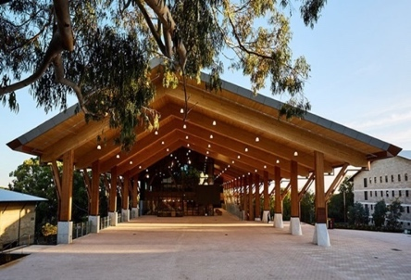
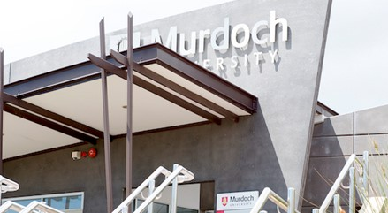
PACs are also available
ONLINE
9am to 7pm Monday to Friday

Guide only: Subject to change when PACs are sick, on prac, etc.
Scan to visit us
Online!
Mandurah
Building 101.1.001
10:30AM
-
1:30PM
Student Central
Building 360.3.046

